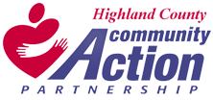

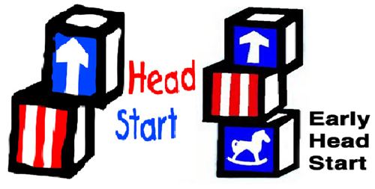
Highland County Community Action Organization, Inc.
Head Start/Early Head Start
Annual Report to the Public
Program Year 2022-2023
Fiscal Year November 1, 2022 - October 31, 2023
HCCAO Head Start/ Early Head Start
Annual Report to the Public
2022-2023 Program Year

Highland County Community Action operates a publicly funded
preschool/infant-toddler program that serves primarily low-income children.
We enroll pregnant women, infants, and toddlers in our Early Head Start
Program and 3-5-year old’s in our Head Start Program who meet eligibility
guidelines. We reserve at least 10% of our enrollment for children with disabilities.

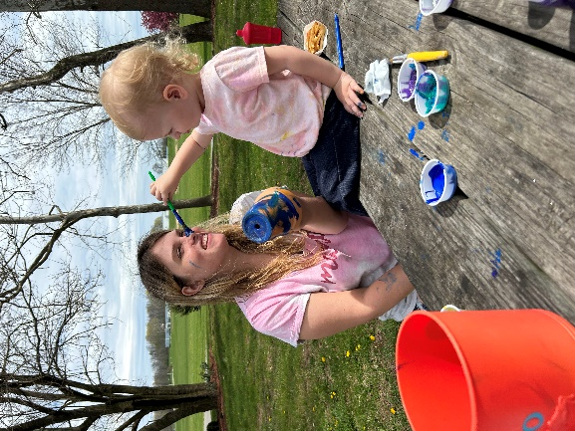
Our Head Start program operates in two separate facilities – Hillsboro and Greenfield. Part-day children attend 3 ½ hour classes 4 days a week, in either
the morning or the afternoon. Full-day children attend 7-hour classes 4 days a week and every other Friday.

Our Early Head Start Program is made up of both center-based and home-based options. There is an infant-toddler classroom in the Hillsboro Center and Greenfield Center for children 6 weeks-36 months. Our home base component consists of weekly home visits and bi-weekly socializations.

- Fiscal Year 2023 Budgets
The HCCAO Head Start/ Early Head Start Program received $3,291,277 from a continuation grant through the Administration of Children and Families for the operation of the program for 2022-2023. Our nonfederal share (in-kind) was $822,819. We also received $41,717 for training and professional development.
The budget is broken down into the following components:
- Personnel $1,732,702
- Fringe $693,079
- Travel $1,000
- Equipment $0
- Supplies $28,828
- Contractual $6,500
- Other $298,900
- Indirect Costs $488,551

The HCCAO Head Start/Early Head Start Program received $260,732 from a Cost-of-Living Assistance (COLA) and Quality Improvement supplemental grant through the Administration of Children and Families for the operation of the program for 2022-2023. Our nonfederal share (in-kind) was $0.
The budget is broken down into the following components:
- Personnel $160,710
- Fringe $61,421
- Indirect Costs $38,601

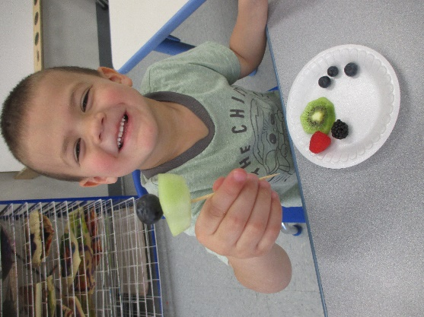
The Child and Adult Food Care Program (CACFP) is a program that is run by the United States Department of Agriculture. Through this program, we are reimbursed a certain percentage for every meal (breakfast and lunch) and every snack that we serve to enrolled children. This year, we received a total of $151,204 in reimbursements.

Our Greenfield Head Start center qualifies to receive additional funding provided through the Ohio Department of Education. This funding source provides services for 27 children through the Early Childhood Expansion grant. At a rate of $4,000 per slot filled we received $108,000 during fiscal year 2023.

The HCCAO Early Childhood Program received an ARP Homeless Support Grant for FY23-24 in the amount of $16,500. This funding is to be used to support families who are experiencing homelessness as defined by McKinney-Vento.

The HCCAO Early Childhood Program received a Parenting and Pregnancy Grant through Ohio Department of Job and Family Services for FY23-25 in the amount of $150,000. This funding is to be used to support pregnant women and children up to 12 months old.

The HCCAO Early Childhood Program received a grant in the amount of $28,337 from the Ohio Children’s Trust Fund. This funding was used to build stronger relationships between parents and children through a “THRIVE” Night event.

- Services Provided – Head Start
Funded Federal Enrollment – 171
Total Number of Children Served – 194

Eligibility – Head Start
Income below 100% of poverty – 90 (46%)
Receipt of Public Assistance such as TANF, SSI – 52 (27%)
Foster Children – 12 (6%)
Homeless Children – 1 (0%)
Over income – 17 (9%)
100-130% income- 22 (11%)

Services Provided – Early Head Start
Funded Federal Enrollment – 72
Total Number of Children Served – 73

Eligibility – Early Head Start
Income below 100% of poverty – 37 (51%)
Receipt of Public Assistance such as TANF, SSI – 10 (14%)
Foster Children – 7 (10%)
Homeless Children – 2 (3%)
Over income – 7 (10%)
100-130% income- 10 (14%)

- Audits and Reviews
Our last annual agency financial audit was completed in September 2022 with one finding of material noncompliance. The audit of the 2022 calendar year is still in process.

Our program had a Focus Area 1 Review, conducted by the Administration of Children and Families, in May 2022. We were found to be in full compliance with all Federal Head Start/Early Head Start regulations.

Our program had a deficiency in the area of “reporting” from March 10, 2022 and a noncompliance in the area of “discipline” from March 10, 2022. Additionally, the program has received a noncompliance in the area of “supervision” from July 5, 2022 and a deficiency in the area of “supervision” from March 6, 2023.

- Medical and Dental Exams
Children Receiving Medical Exams – Head Start – 143 (74%)
Children Receiving Dental Exams – Head Start –133 (69%)

Children Receiving Medical Exams – Early Head Start – 38 (52%)
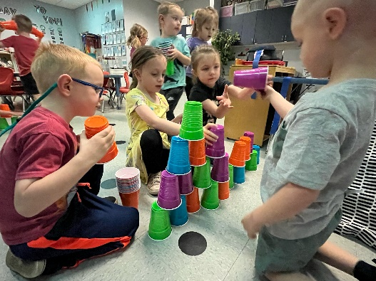
Children who are up-to-date on preventive oral care–Early Head Start– 6 (8%)

- Parent Involvement Activities
Throughout the 2022-2023 program year, parents in our program had various opportunities to participate through:
- Policy Council and Governing Board
- Parent/Teacher Conferences
- Take Home Activities
- Workshops and Trainings
- Home Visits
- Socializations (Early Head Start Home Base)

- Kindergarten Preparation
Head Start staff is committed to making the transition from Head Start to Kindergarten as successful as possible. In order to facilitate this transition, teachers use the Creative Curriculum in their classrooms. This curriculum aligns with the Ohio Early Learning and Development Standards, the Head Start Framework, the program’s school readiness goals, and our child assessment program, Desired Results Developmental Profile (DRDP). This curriculum provides tools to allow teachers to individualize lessons to each child, ensuring that each child is being appropriately challenged, which will in turn, allow each child to learn to his or her fullest potential.

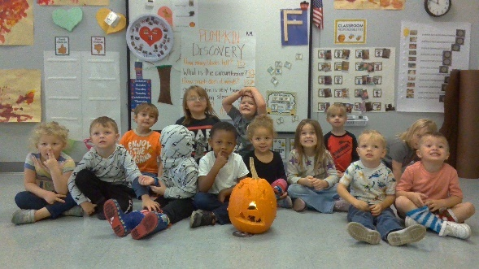
We also maintain open communication and cooperation with parents, early intervention programs, and the local school districts. Children are taken on field trips to local kindergarten classrooms. Additionally, they are shown the video “Kindergarten, Here I Come” and practice kindergarten-like routines in the Head Start classroom. Parents and school districts are also invited to be involved in the decision-making process around the program’s school readiness goals.

Parents are encouraged to be fully involved in the transition process between Head Start and Kindergarten. Teachers conduct two home visits a year, where a parent’s educational goals for a child can be made and assessed. Teachers also share information on an individual child’s progress through the year with parents in conferences and home visits. Parents are encouraged to attend the kindergarten field trips, and are provided with information pertaining to kindergarten registrations and orientations.

